COUNT AND COLOUR ME!
- COLOUR THE PICTURE BELOW SO THAT THE TILES OF THE SAME SHAPE ARE COLOURED THE SAME.
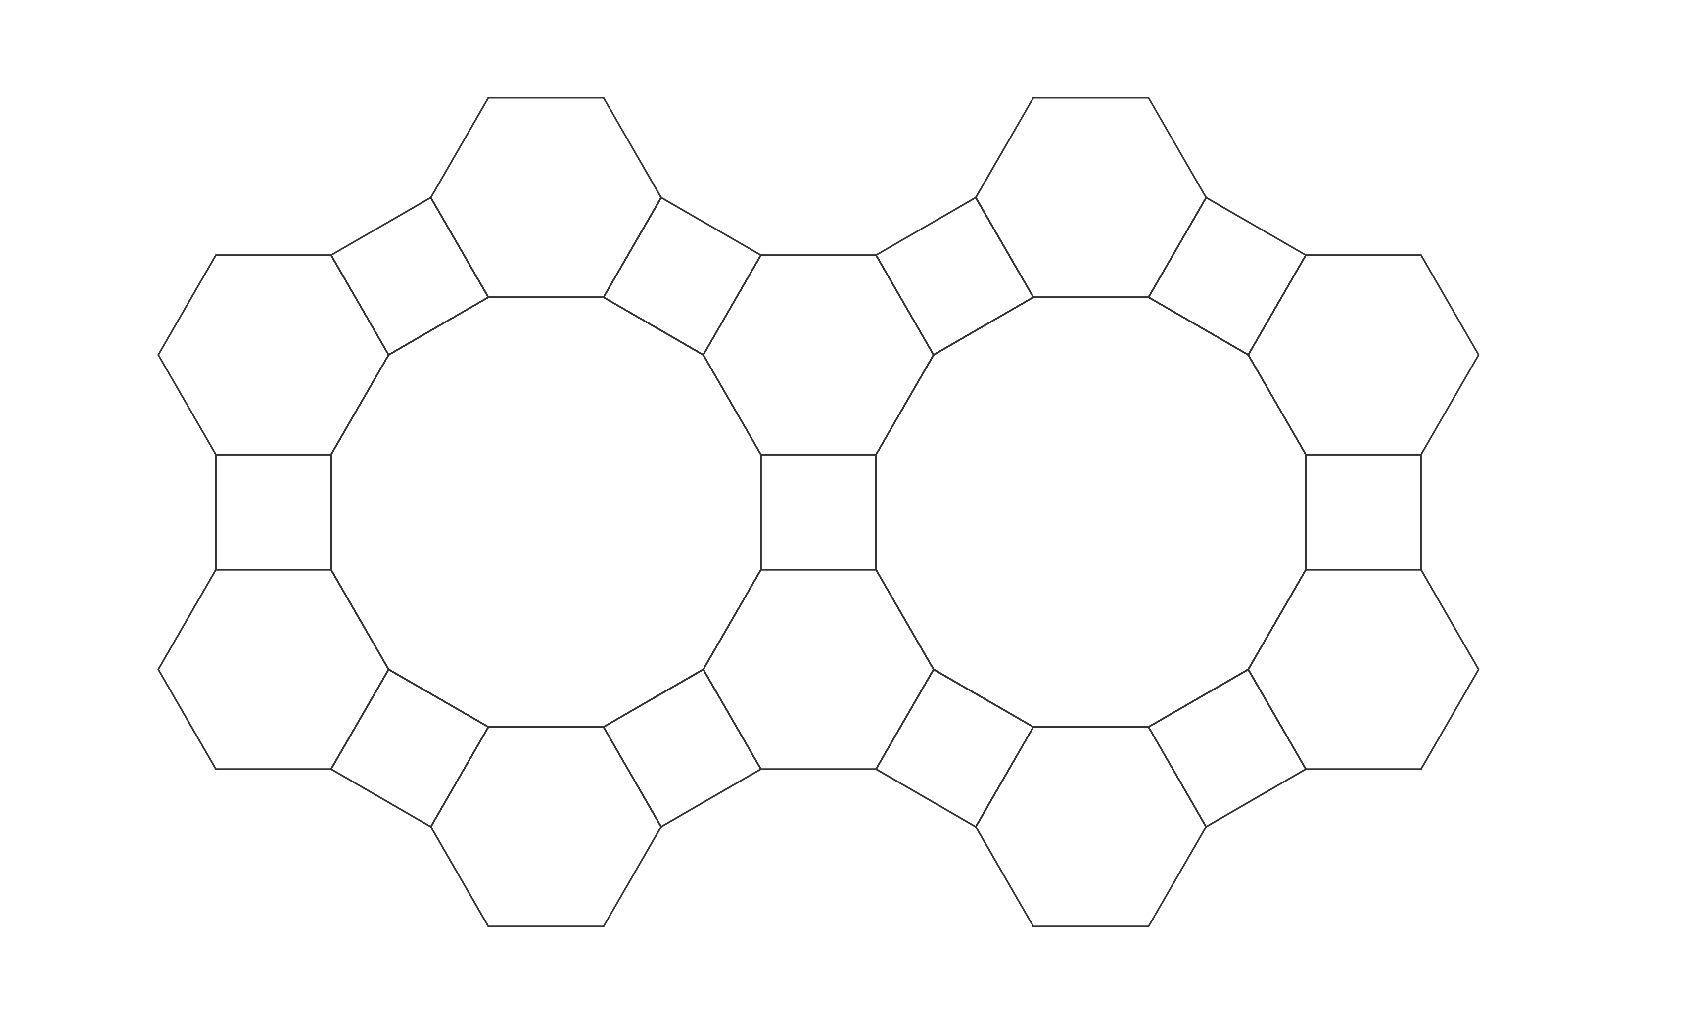
COLOUR | NUMBER OF TILES
- DIVIDE THE RECTANGLE INTO MULTIPLE PARTS USING 6 CURVED LINES.
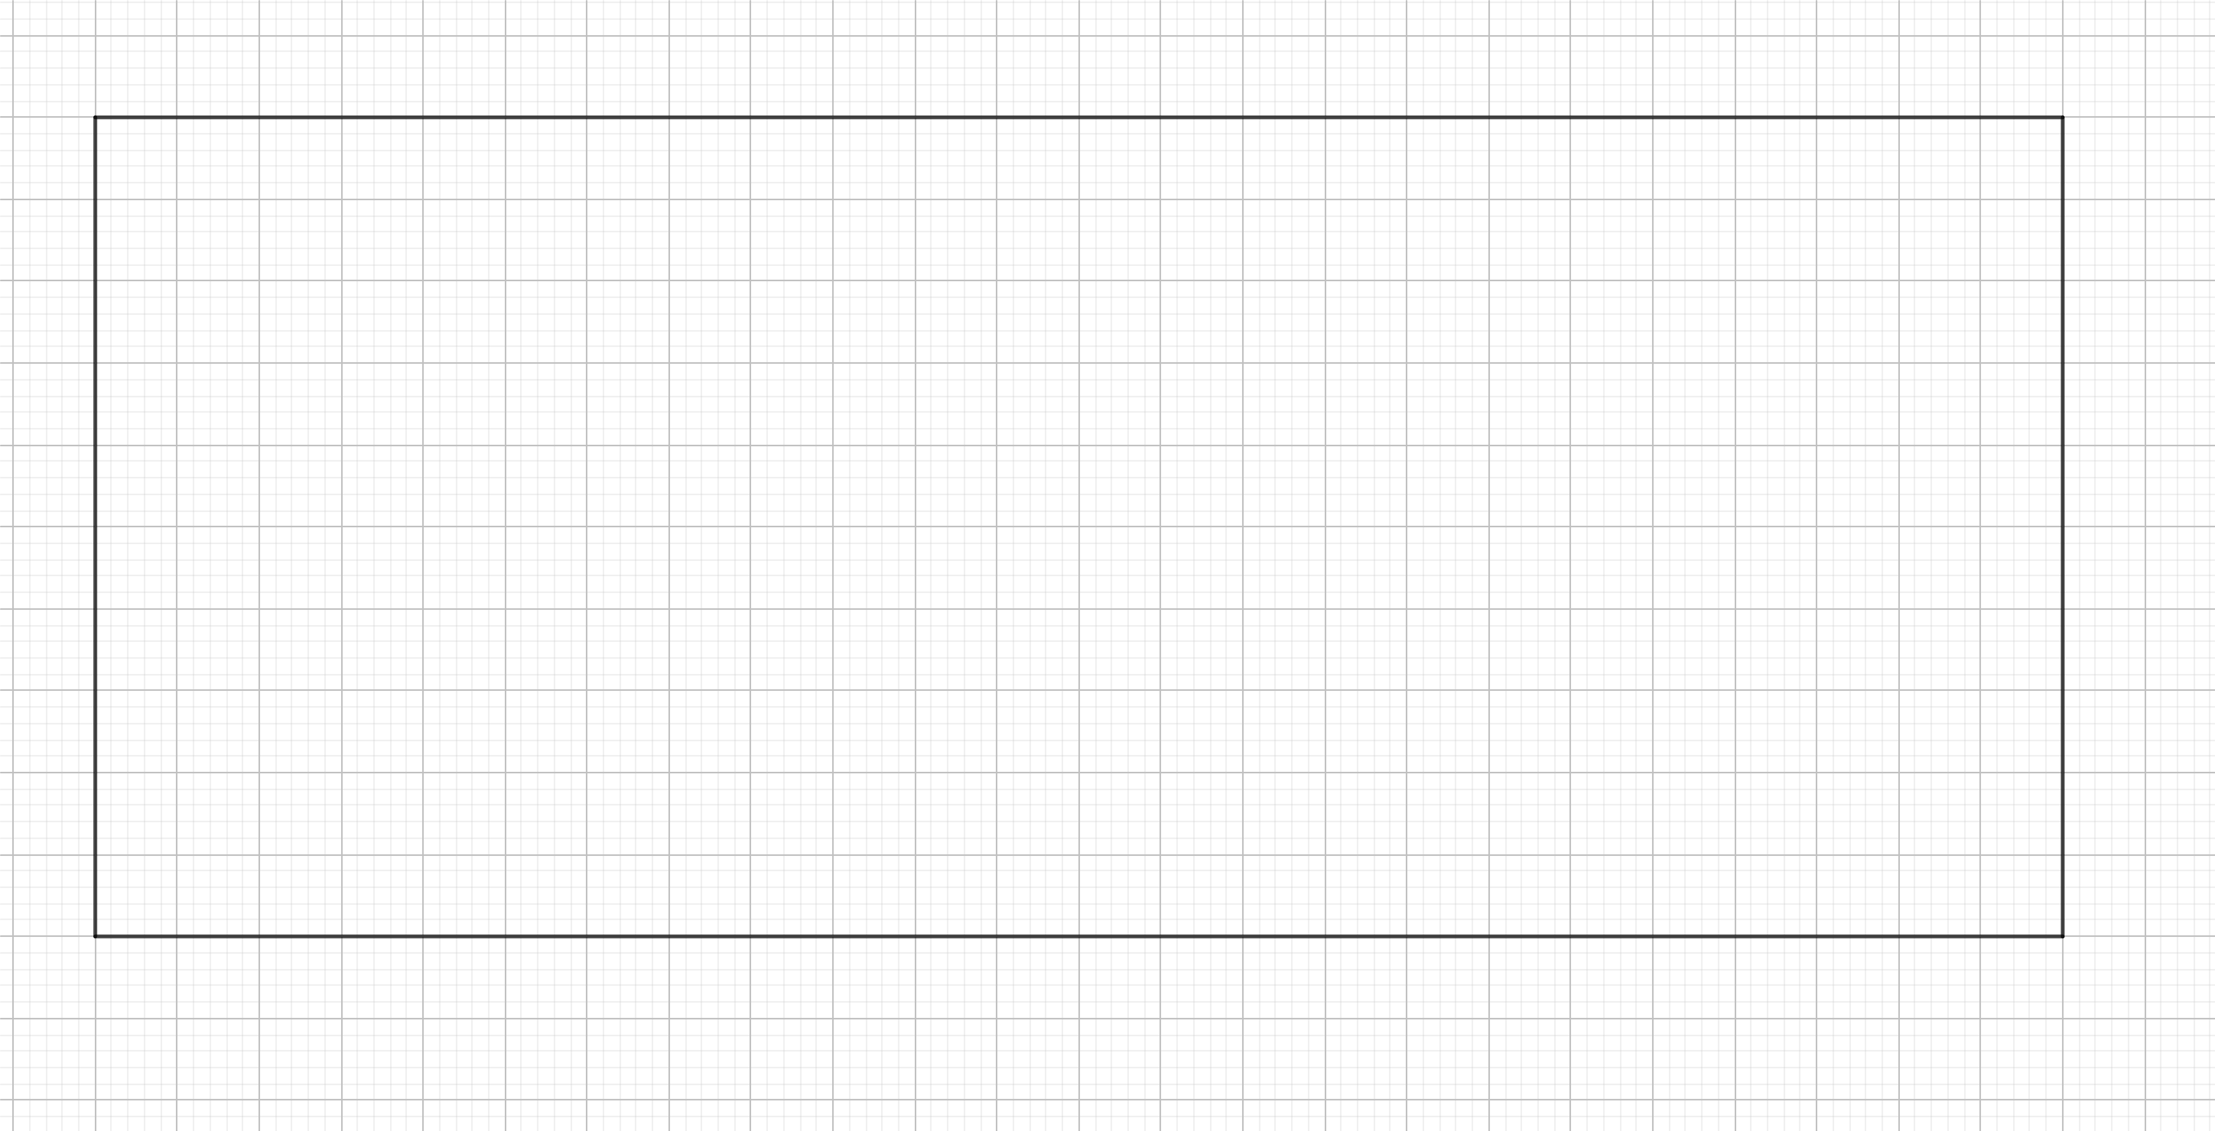
NUMBER OF TILES
- DIVIDE THE RECTANGLE INTO 10 TILES USING STRAIGHT LINES AND PAINT EACH TILE A DIFFERENT COLOUR.
- DIVIDE THE RECTANGLE INTO MULTIPLE TILES IN THE SHAPE OF A RECTANGLE.
PAINT EACH TILE ONE COLOR, BUT SO THAT TWO ADJACENT TILES ARE NOT PAINTED THE SAME.
NUMBER OF TILES
IS THERE A SQUARE BETWEEN THEM?
- DRAW STRAIGHT LINES SO THAT YOU HAVE AT LEAST 2 TILES IN THE SHAPE OF A SQUARE.
PAINT EACH TILE SO THAT TWO ADJACENT TILES ARE COLORED DIFFERENT
COLOUR. TRY TO USE AS FEW DIFFERENT COLOURS AS POSSIBLE.
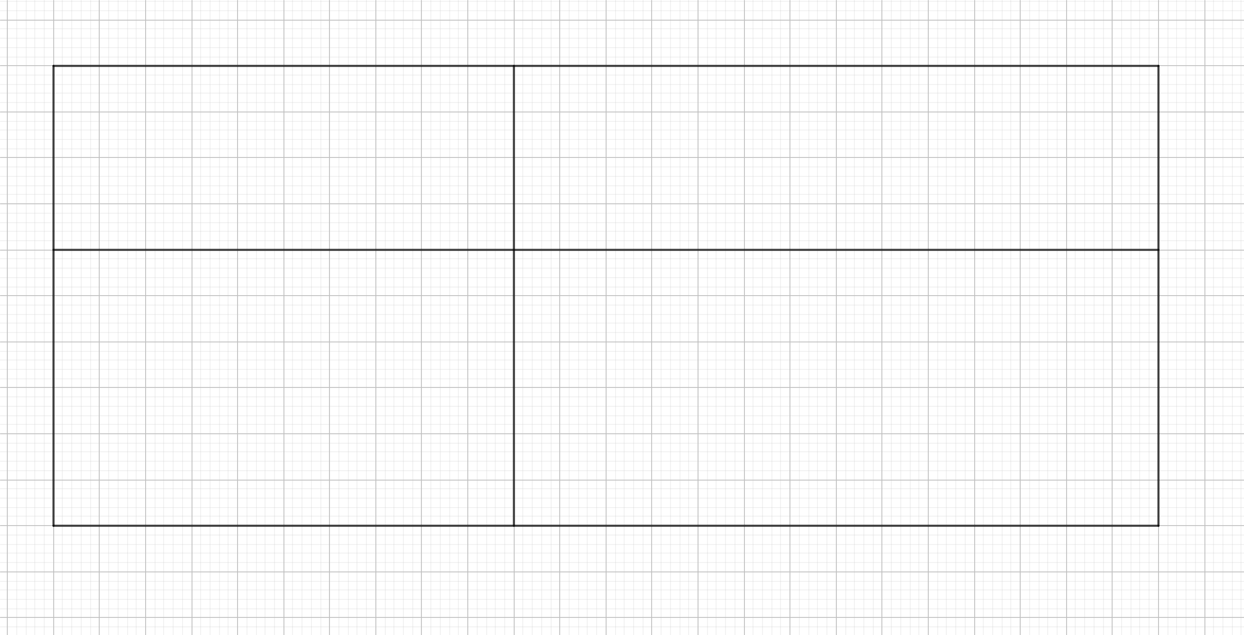

NUMBER OF COLOURS
NUMBER OF SQUARES
NUMBER OF RECTANGLES THAT ARE NOT SQUARES
- DIVIDE THE RECTANGLE INTO AS MANY TILES YOU WANT. YOU CAN USE BOTH STRAIGHT AND CURVED LINES.
PAINT EACH TILE SO THAT TWO ADJACENT TILES ARE COLOURED DIFFERENT COLOURS. USE A MAXIMUM OF 4 DIFFERENT COLOURS.
NUMBER OF COLOURS
- COLOUR THE TILES IN THE FOLLOWING SQUARE.
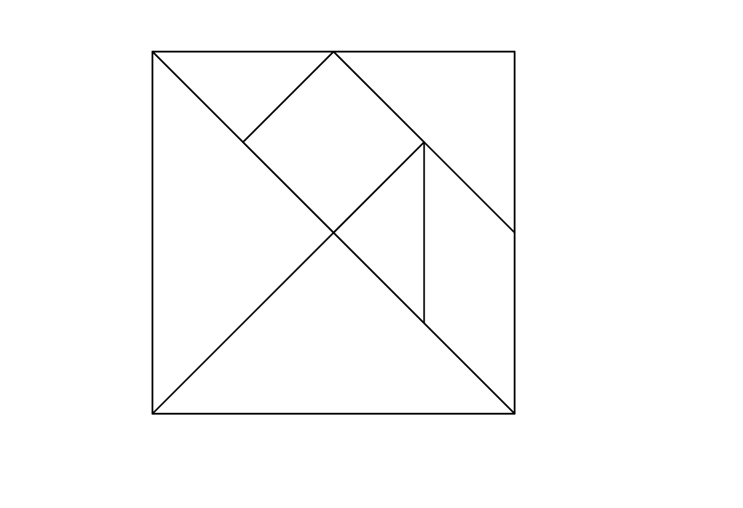
CUT THE TILES AND TRY TO MAKE THE FOLLOWING SHAPES WITH THEM.

