MATH READING
THE STORY OF NUMBERS

We use letters to write words, and we use figures to write numbers.
Do you know what are the figures we use today called? Their name is Arabic numerals. It wasn't before 14th century that people started using these figures. Even though their name is Arabic numerals, they weren't invented by the Arabs. They were invented in India, around 6th or 7th century. It was the Arab people who introduced the Europeans to these figures. The first recording found in Europe, which includes Arabic numerals, was found in 976. Arabic numerals were described in detail by Italian mathematician Fibonacci 226 years later.
It is interesting to note that the layout of the Arabic numerals is related to their value.
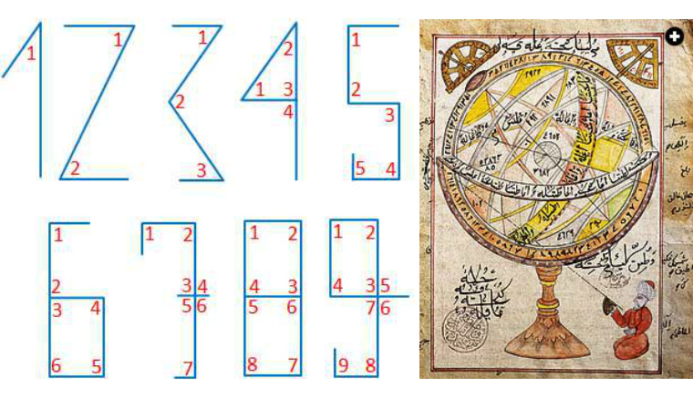
Source: povijest.hr
How did Europeans write the numbers before they learned Arabic numeral? Have you ever seen writing like this: MCMXXII in any old building? Do you know what it means? Those are numbers written in Roman numerals. As their name reveals, Roman numerals were introduced by the Romans. The numbers we will describe in the owing part were used by the Romans since the 1st century. You are soon to find out that writing those numbers wasn’t simple at all. It is interesting to say that zero cannot be written in Roman numerals, and the biggest number possible to be written in Roman numerals is 3999.
HOW DO WE WRITE NUMBERS IN ROMAN NUMERALS?
Numbers are written using these symbols:
SYMBOL | I | V | X | L | C | D | M
VALUE | 1 | 5 | 10 | 50 | 100 | 500 | 1000

Numbers are written according to the following rules:
- Roman numerals are read from left to right.
- Symbols I, X, C and M can be repeated up to three times in a number.
- Roman numbers V, L and D can never be repeated.
- If a number has a symbol on the right with a smaller value than the symbol on the left, the values are added.
- If a number has a symbol on the right with a larger value than the symbol on the left, and it is I, X, or C, then the smaller value is subtracted from the larger value.
- Value I can only be subtracted from values V and X.
- Value X can only be subtracted from L and C V
- Value C can only be subtracted from values D and M.
- Values V, L and D can never be subtracted.
- Only one smaller value can be subtracted from larger value.
QUESTIONS:
- In which century did the Romans start using the Roman numerals?
- In which century was the first recording using Arab numerals found in Europe?
- What year did Fibonacci describe the Arab numerals?
- In what year was a building built, if the year of construction says: CX?

