SCRATCH THE SURFACE!
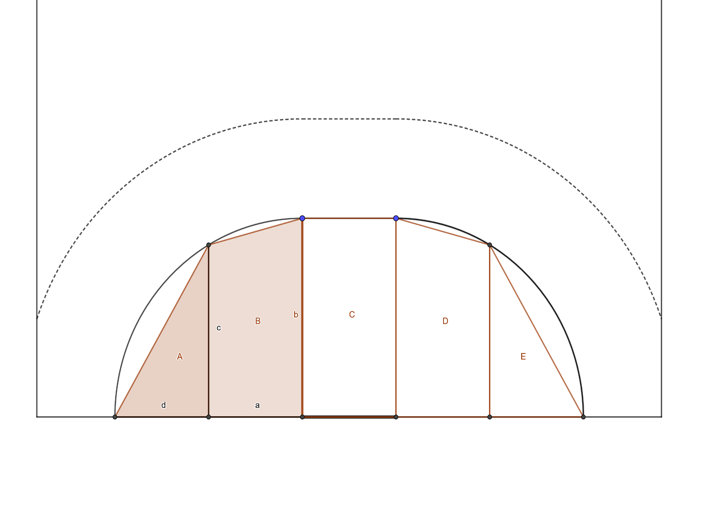
1. Measure!

a = _______ feet b = _______ feet
c = _______ feet d = _______ feet

2. Measure!

A foot = __________ cm

3. Calculate!
CALCULATION:

a = _______ cm b = _______ cm

c = _______ cm d = _______ cm

4. Measure the surface area of the shapes A and B.
CALCULATION:

A = _________ cm², B = _________ cm²

4. Check the results of the others in your group and write down the surface area of the shapes A, B, C, D, E.

A = _________ cm² B = _________ cm² C = _________ cm²
D = _________ cm² E = _________ cm²

5. Calculate total surface area.
CALCULATION:

A+B+C+D+E = _________ cm²

