WHO WILL PRODUCE LESS WASTE
worksheet
- The amount of waste an average household makes in an average day in County of Primorje – Gorski kotar:
 | GLASS  (in grams) | PLASTIC AND METAL  (in grams) | PAPER  (in grams) | OTHER WASTE:  TRASH  (in grams)
Household  (4 persons)  1 day | 115 | 775 | 715 | 1185

- Draw the amount of waste according to the type of waste into this diagram (colour the columns in corresponding colours)
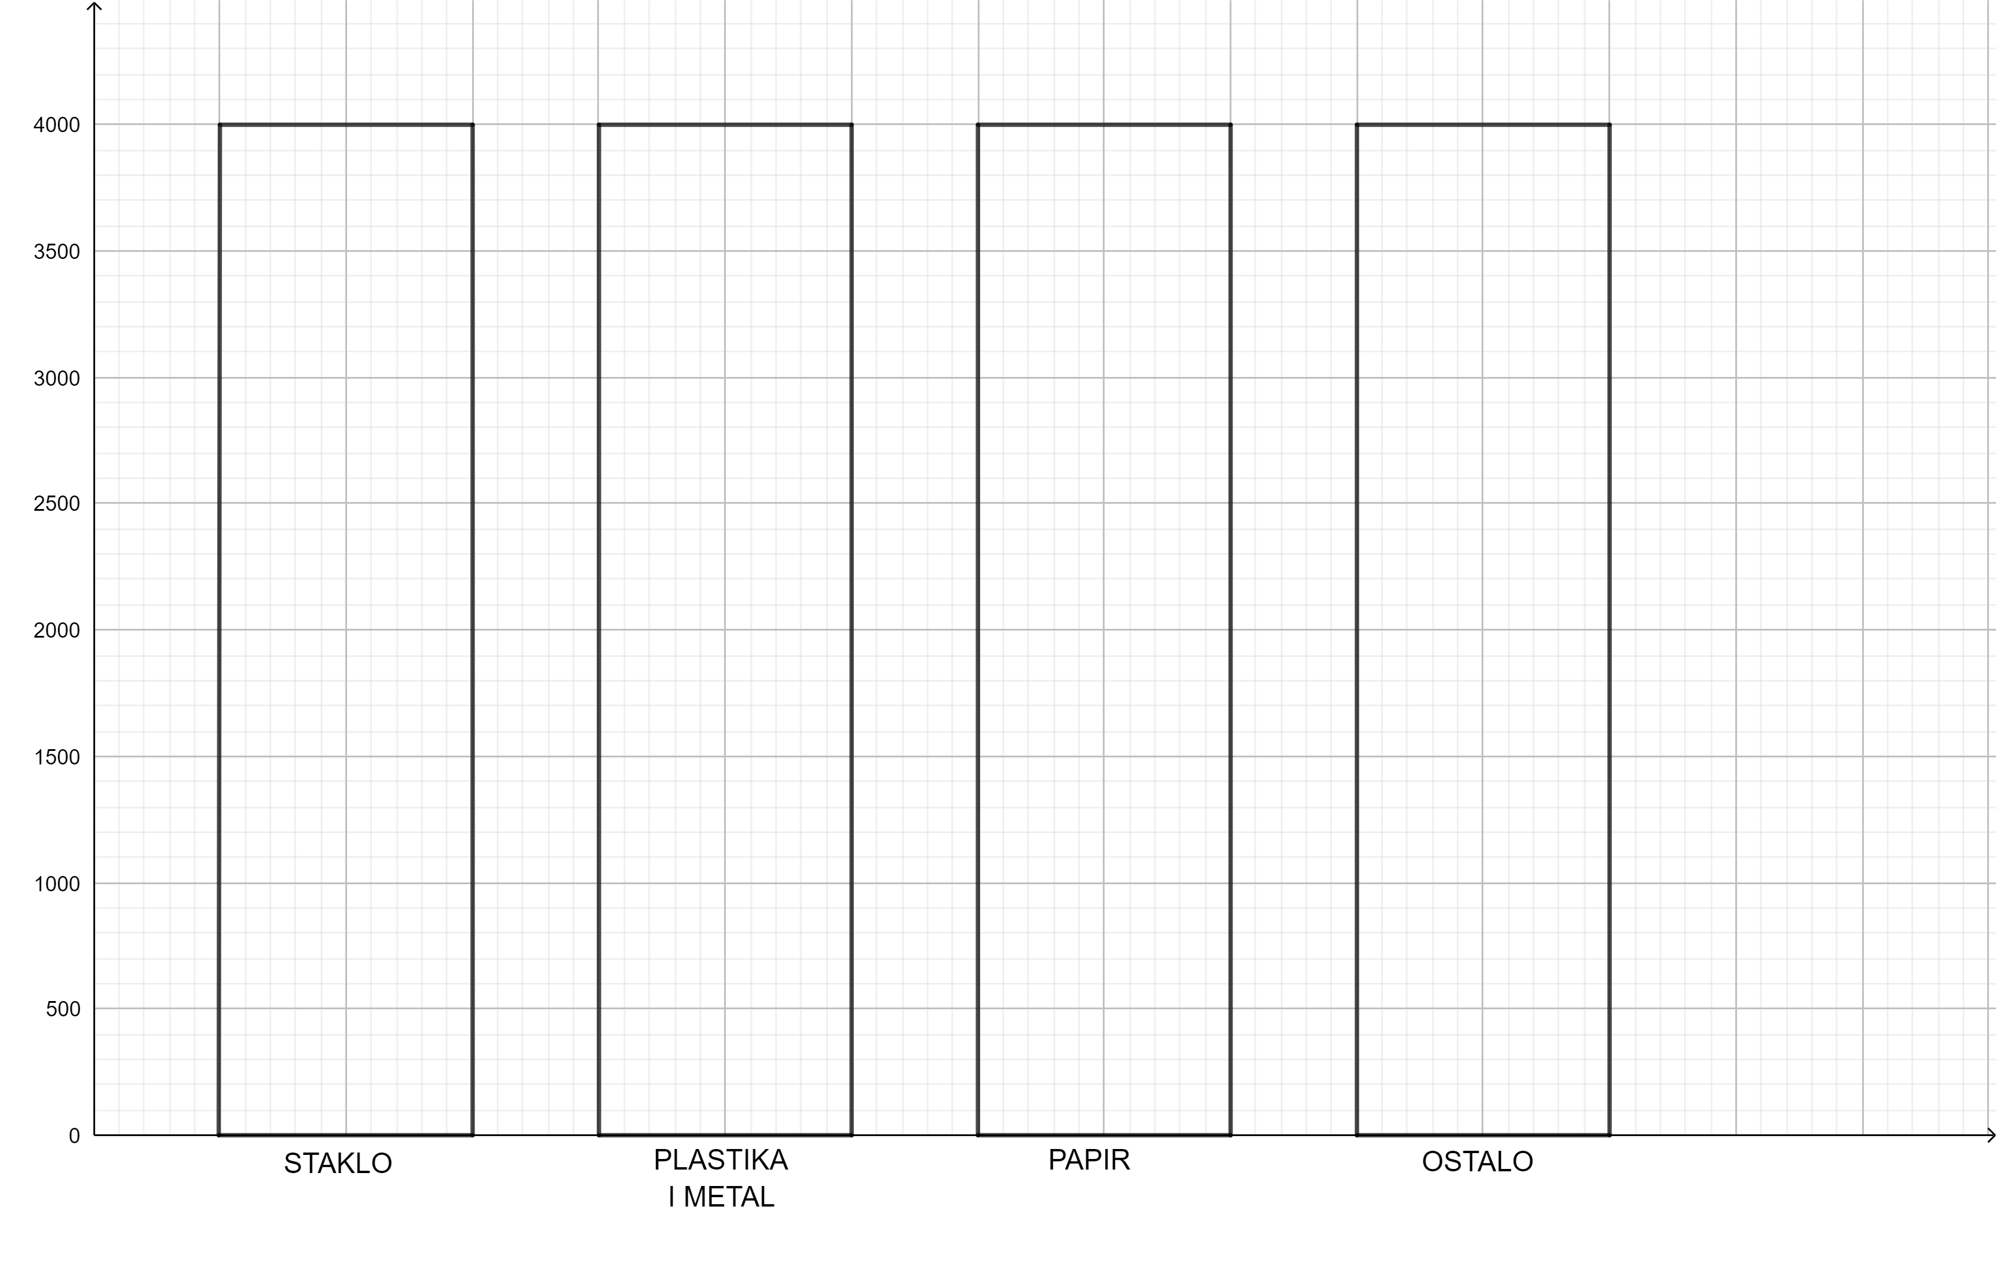
- How many grams of waste did a household make in 1 day?
CALCULATION:

ANSWER

__________________________________________________________________________________

__________________________________________________________________________________

How many grams of recyclable waste is made in a household in one day? | How many grams of trash is made in one household in one day?
CALCULATION: | CALCULATION:
ANSWER: | ANSWER::
How many grams of recyclable waste did a household make in a week? | How many grams of trash did a household make in a week ?
CALCULATION: | CALCULATION:
ANSWER: | ANSWER:

- Draw the amount of trash and the amount of recyclable waste made in a household in a week in the diagram.

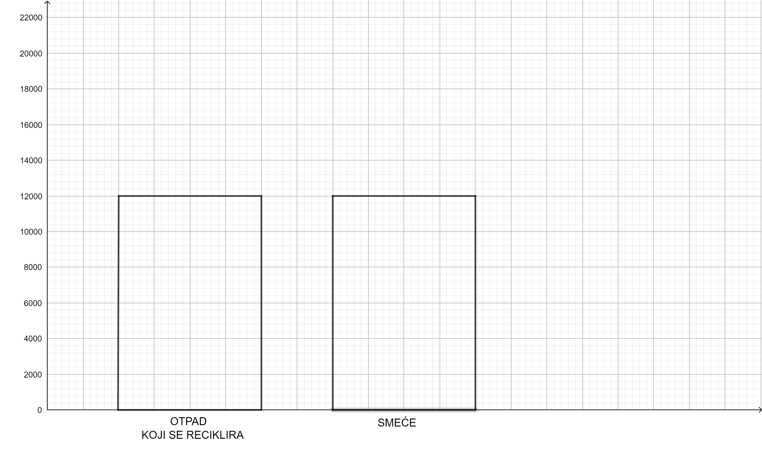

Estimate: How many grams of recyclable waste is produced in a household in a year? | Estimate: How many grams of trash is produced in a household in a year?
CALCULATION: | CALCULATION:
ANSWER: | ANSWER:
Estimate: How many grams of recyclable waste is produced in a household in a year? | Estimate: How many grams of trash is produced in a household in a year?
CALCULATION: | CALCULATION:
ANSWER: | ANSWER:
Estimate: How many grams of recyclable waste does one person make in a year? | Estimate: How many grams of trash does one person make in a year?
CALCULATION: | CALCULATION:
ANSWER: | ANSWER:

- Municipality Viškovo has a population of 16000 residents.
Estimate: How many grams of recyclable waste does Municipality Viškovo make in a year? | Estimate: How many grams of trash does Municipality Viškovo make in a year?
CALCULATION: | CALCULATION:
ANSWER: | ANSWER:

WHY RECYCLING IMPORTANT?

