ZAGREBI PO POVRŠINI
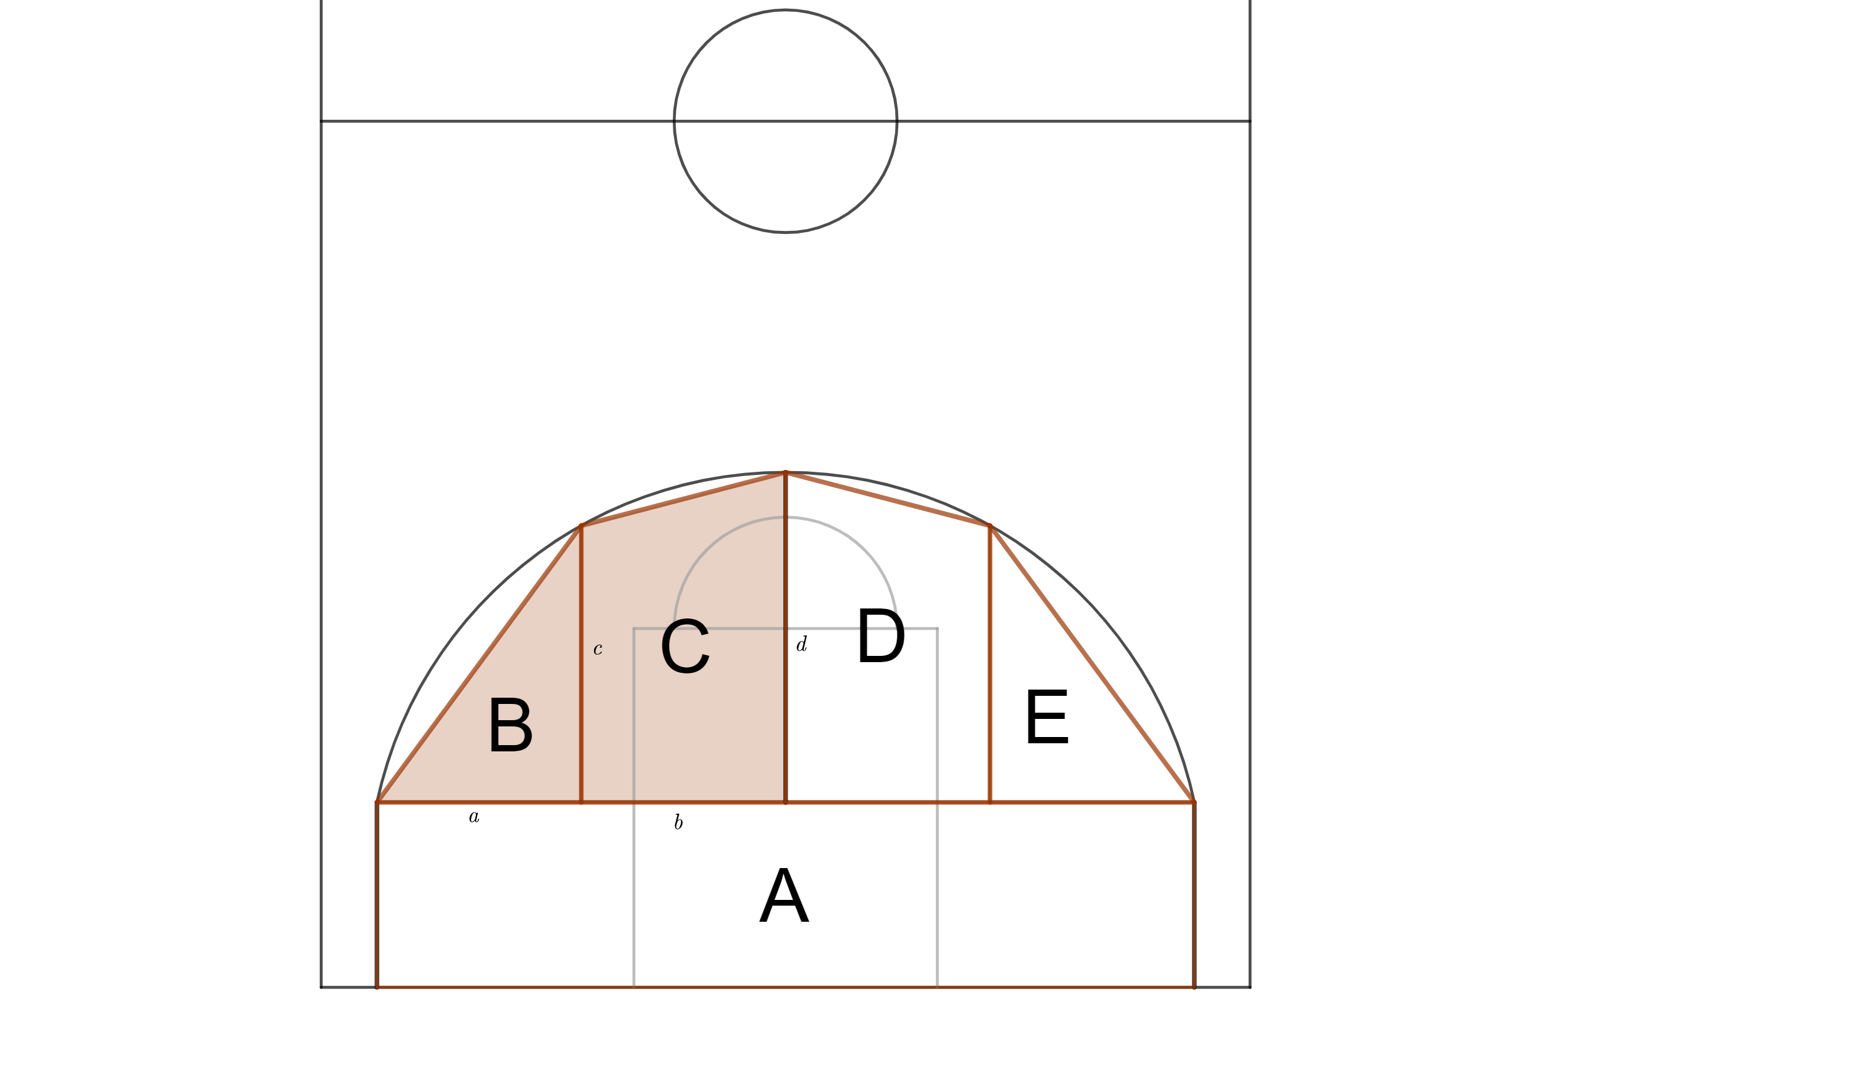
1. Measure!

a = _______ feet b = _______ feet
c = _______ feet d = _______ feet
2. Measure!

A foot = __________ cm

3. Calculate!
CALCULATION:
a = _______ cm

b = _______ cm
c = _______ cm
d = _______ cm

3. Calculate the surface area of shapes B and C.

CALCULATION:

B = _________ cm² C = _________ cm²

4. Take a look at the results of the rest of your group and write down the square areas for shapes A, B, C, D, E.

A = _________ cm² B = _________ cm² C = _________ cm²
D = _________ cm² E = _________ cm²

5. Calculate the total square area.
CALCULATION:

A+B+C+D+E = _________ cm²

