NEIGHBOURHOOD: NUMBER
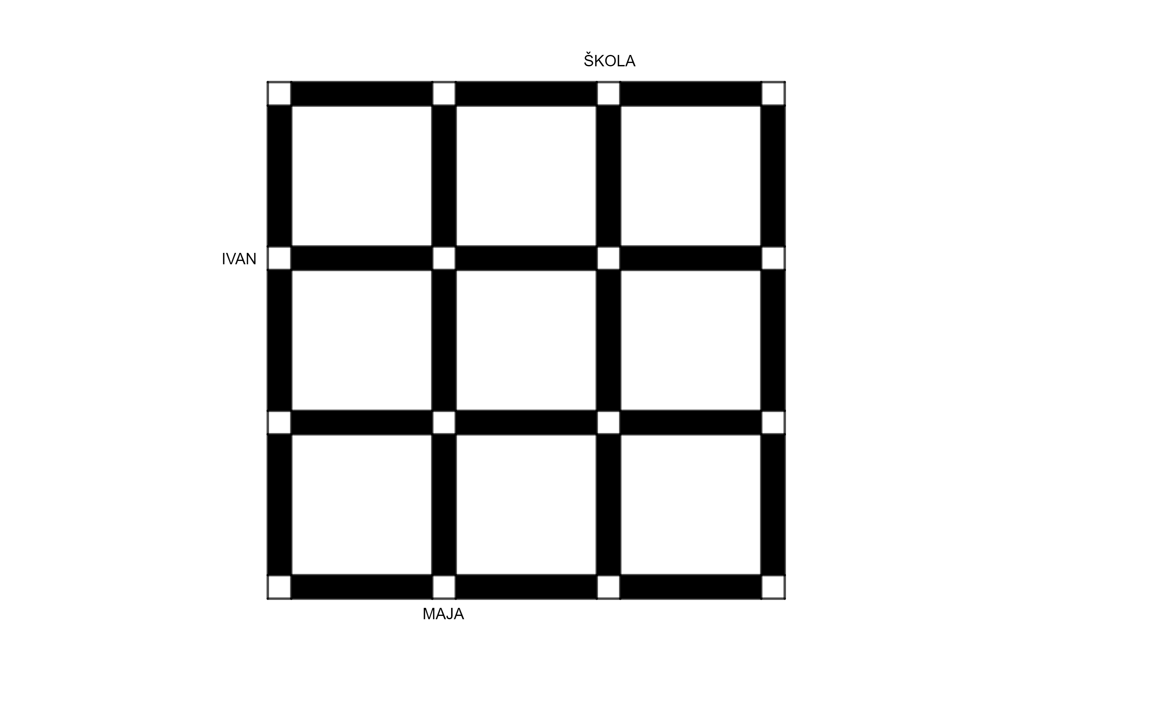

NEIGHBOURHOOD: LETTER
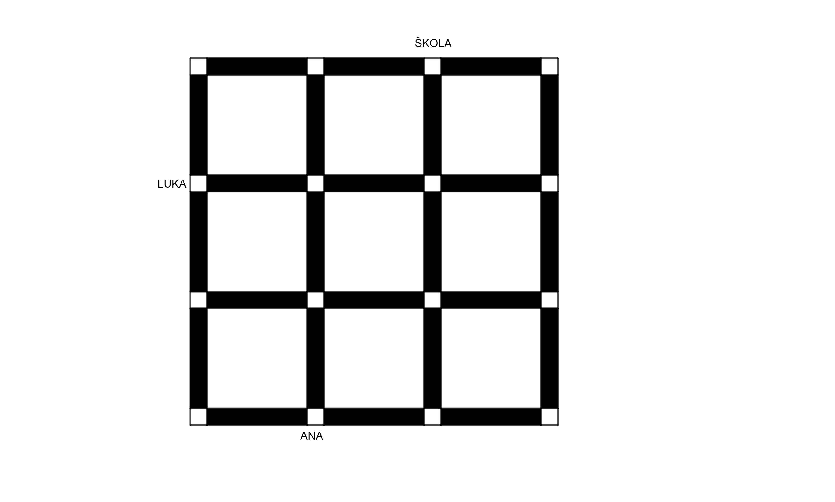

NEIGHBOURHOOD: POINT
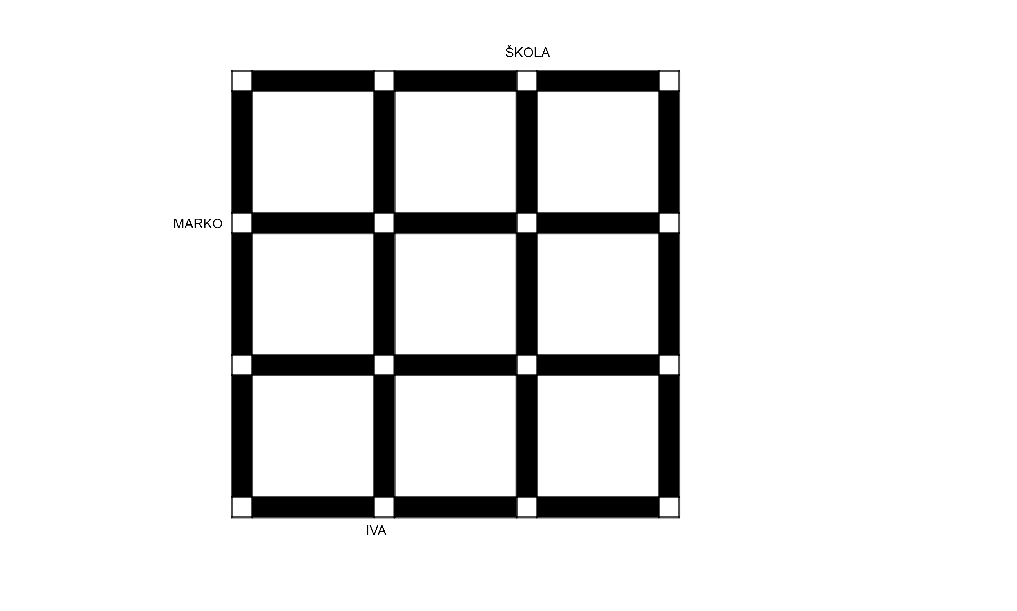

NEIGHBOURHOOD: CUBE
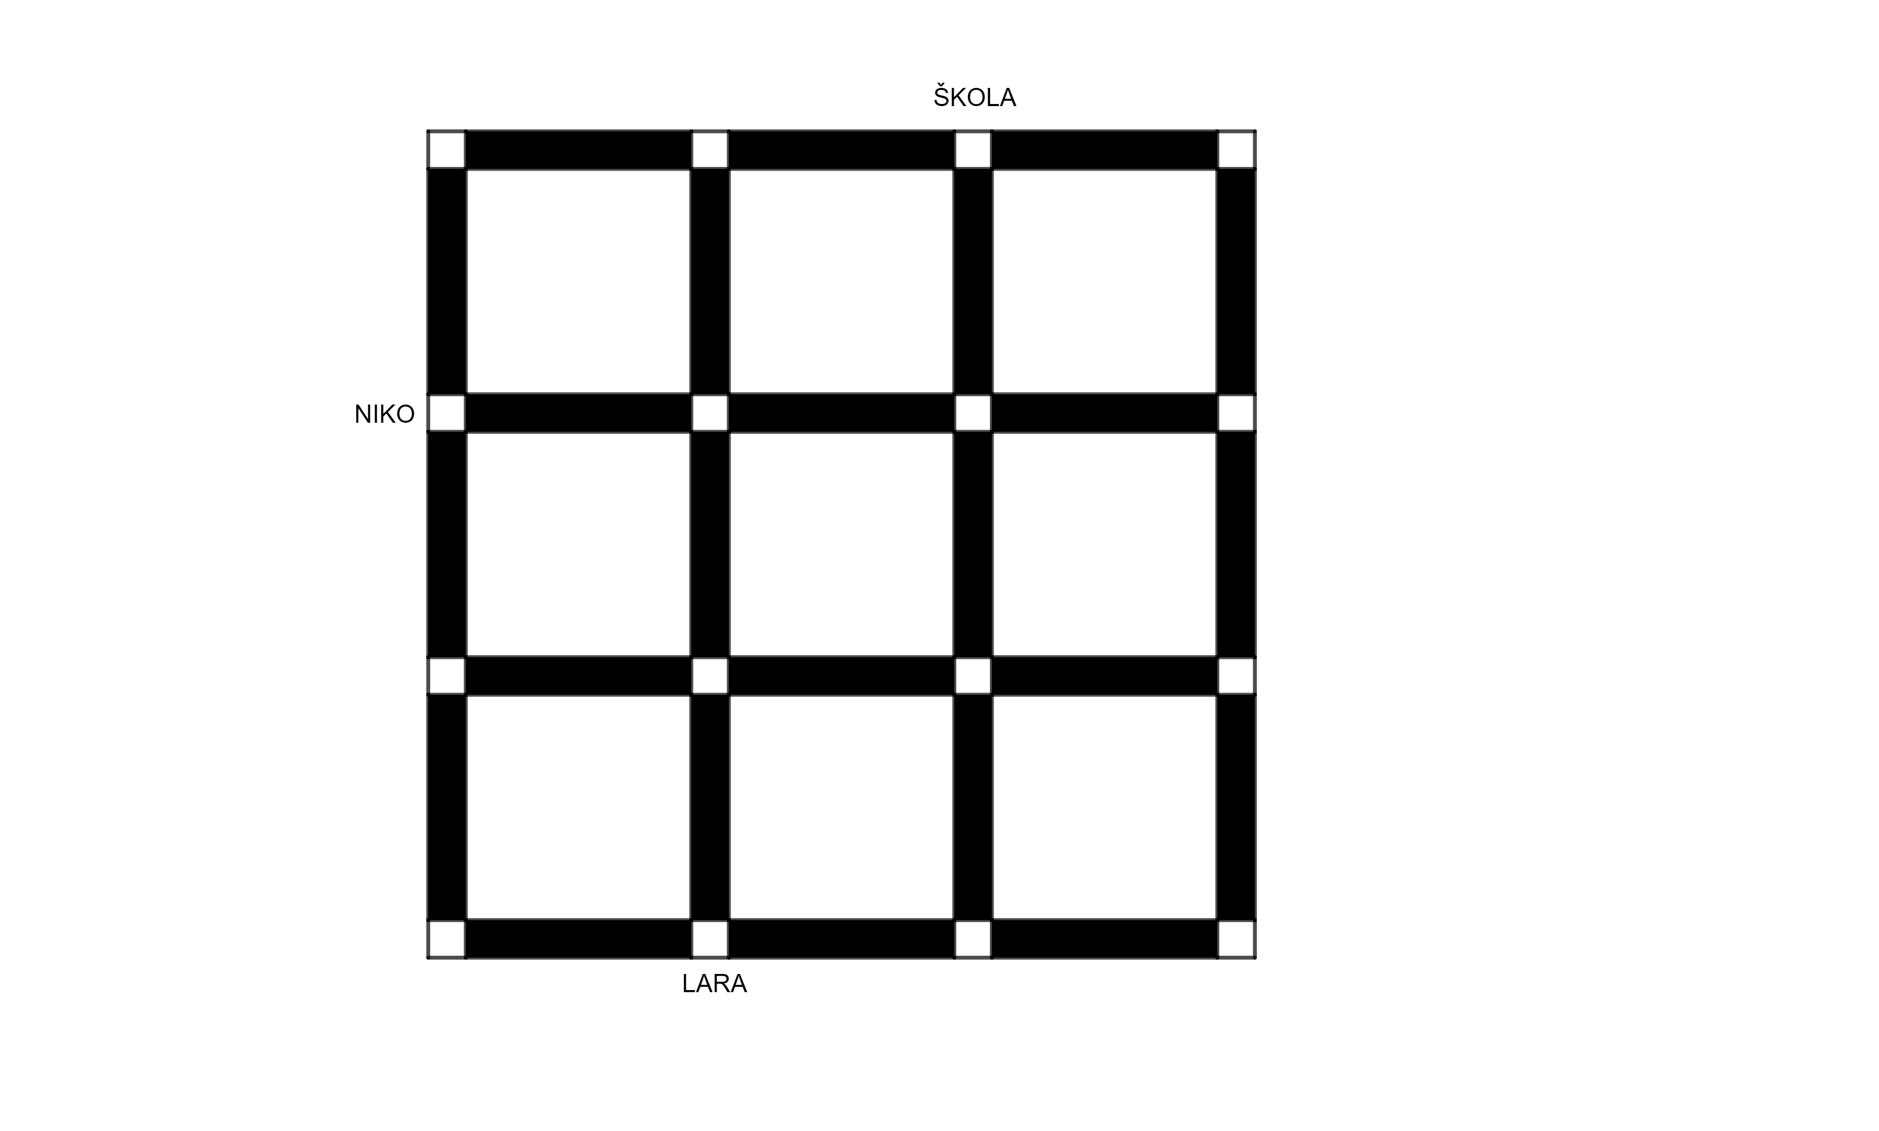

CITY: MATKOGRAD

