PICTIONARY
CONE | SPHERE | ROUND SOLID WITH HOLE
PYRAMID | CUBOID | CYLINDER
TRIANGLE | SQUARE | 6-SIDED PLANE SHAPE
7-SIDED PLANE SHAPE | 8-SIDED PLANE SHAPE | CUBE
EDGE | FACE | SIDE
FLAT SURFACE | CURVED SURFACE

ALIAS

CONE | SPHERE | ROUND SOLID WITH HOLE
PYRAMID | CUBOID | CYLINDER
TRIANGLE | SQUARE | 6-SIDED PLANE SHAPE
7-SIDED PLANE SHAPE | 8-SIDED PLANE SHAPE | CUBE
ANGULAR SOLID | ROUND SOLID | SOLID SHAPE
RECTANGLE | PLANE SHAPE | EDGE
FACE | SIDE | FLAT SURFACE
CURVED SURFACE

MEMORY

CONE | CYLINDER | SPHERE
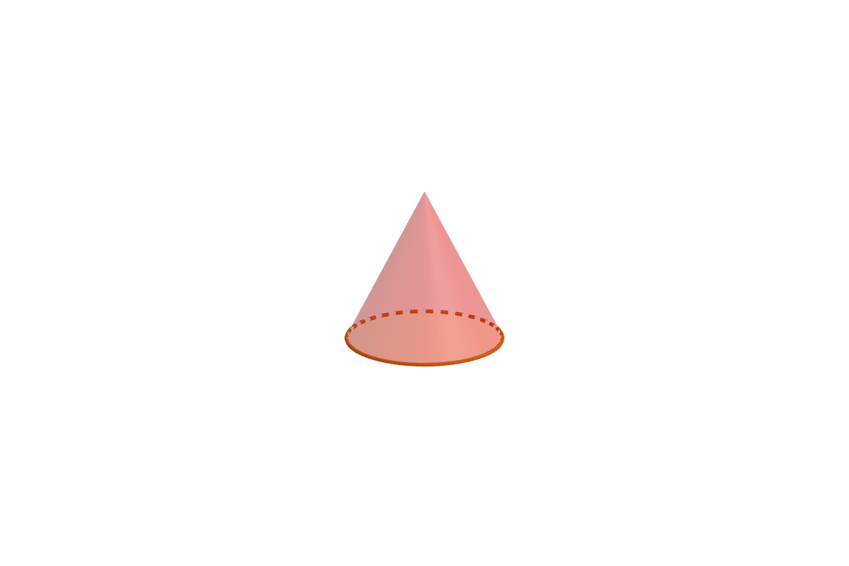 | 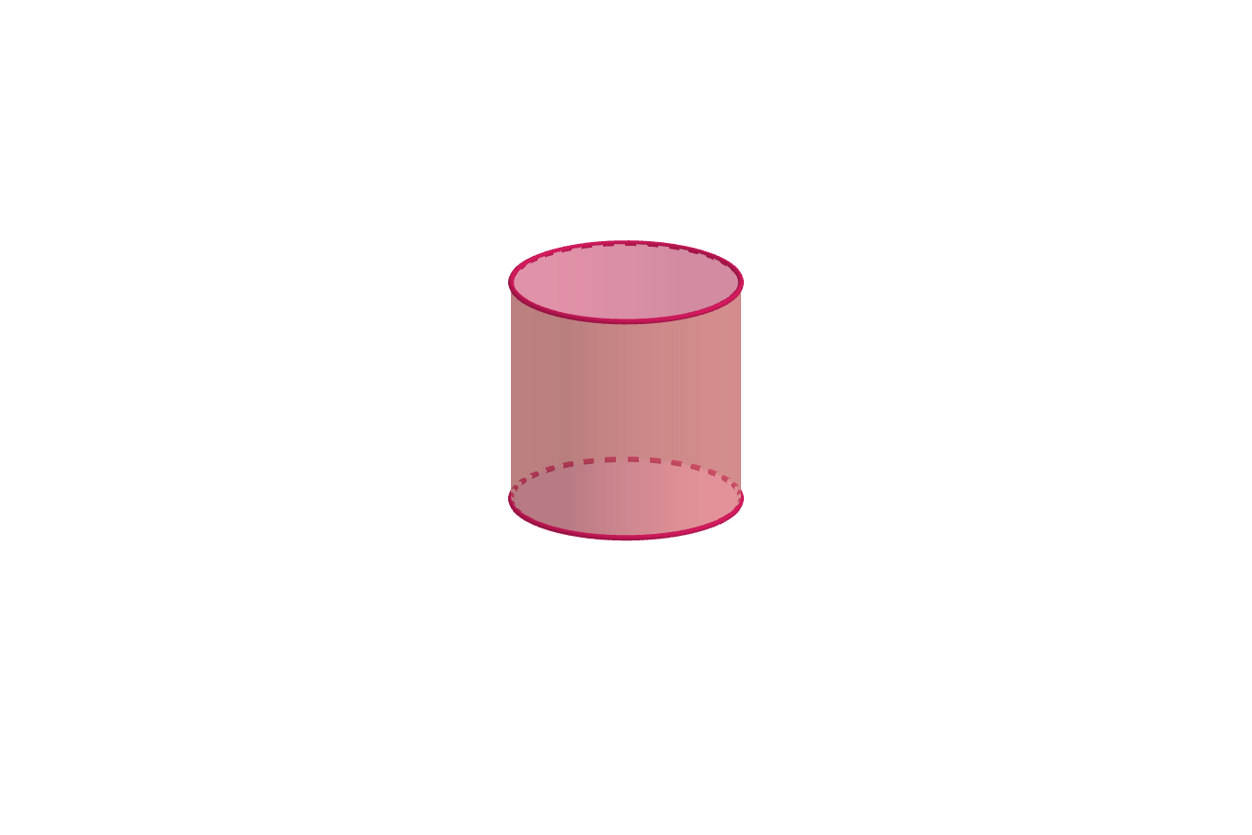 | 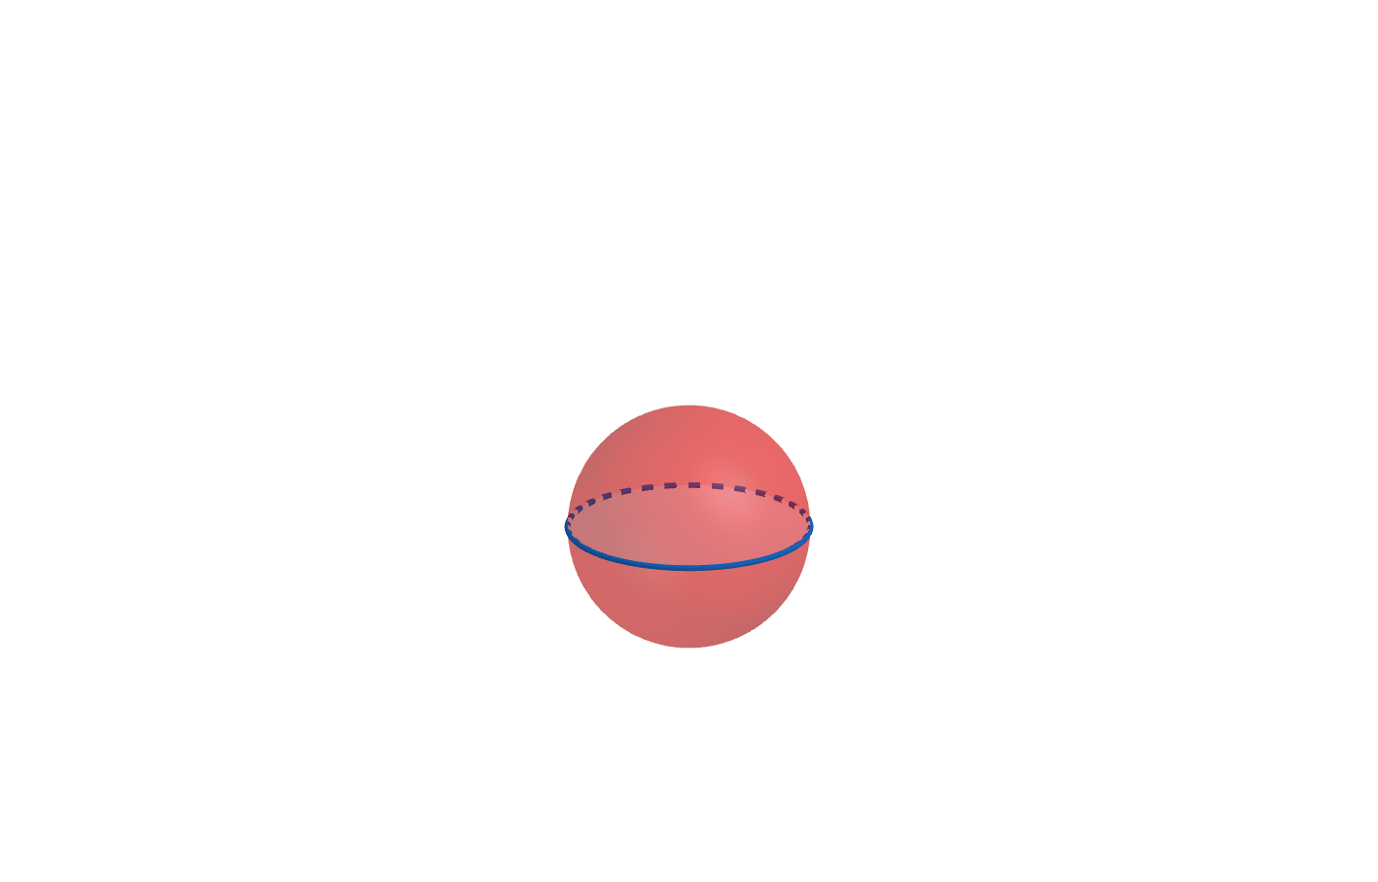
PYRAMID | CUBOID | ANGULAR SOLID WITH 5 SIDES: TWO TRIANGLES AND 3 RECTANGLES
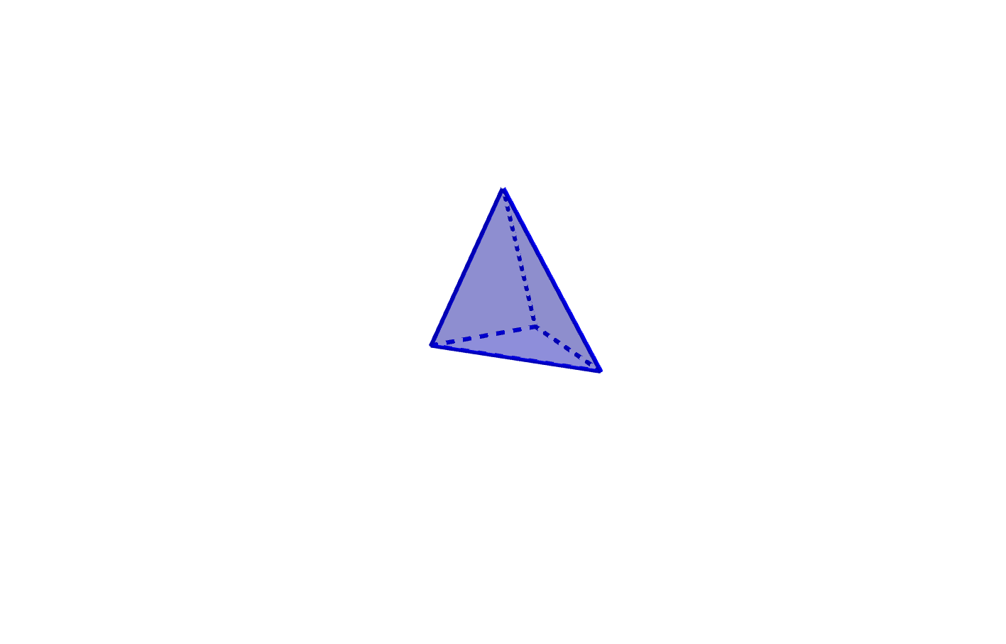 | 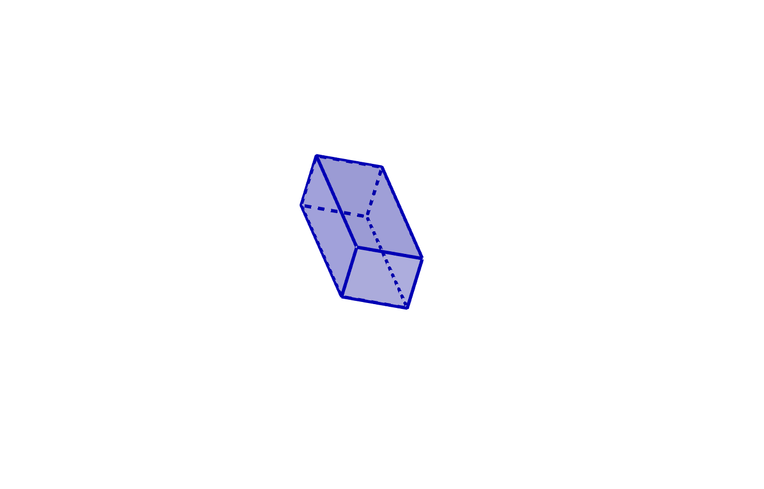 | 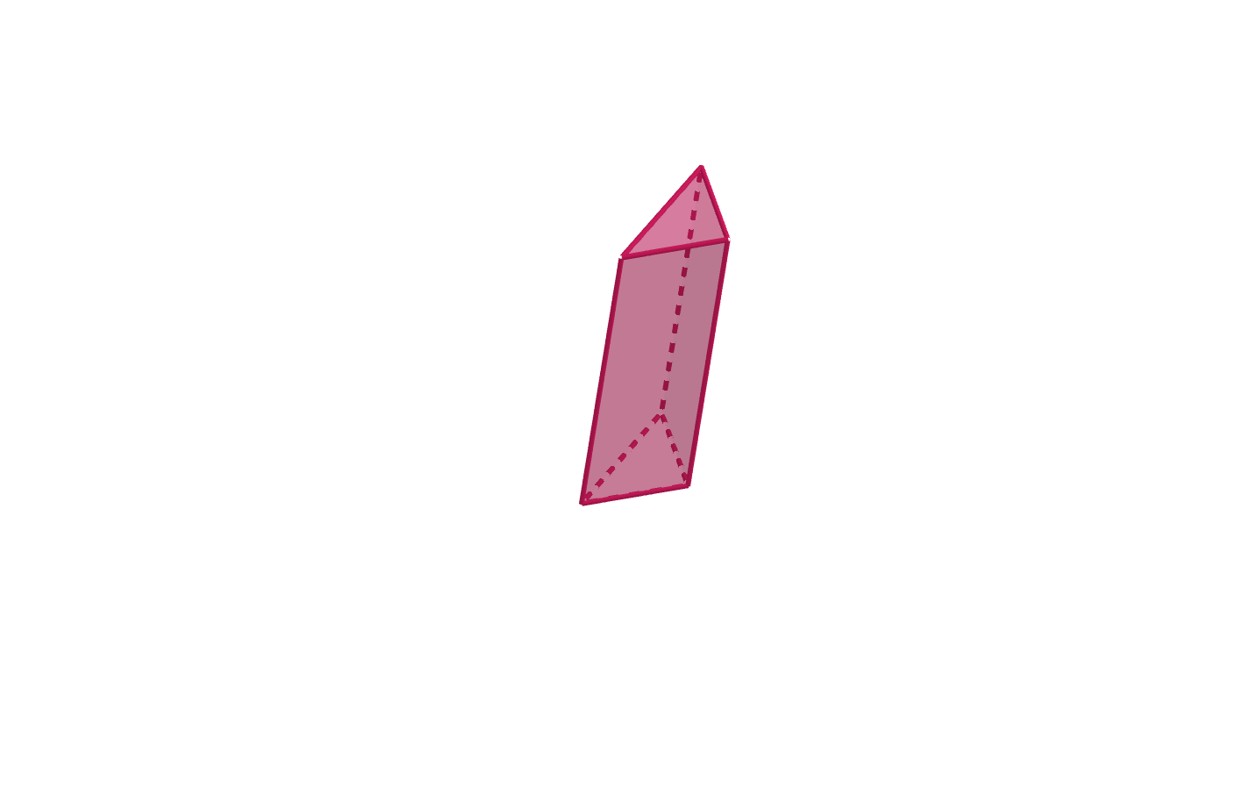
TRIANGLE | SQUARE | 6-SIDED PLANE SHAPE
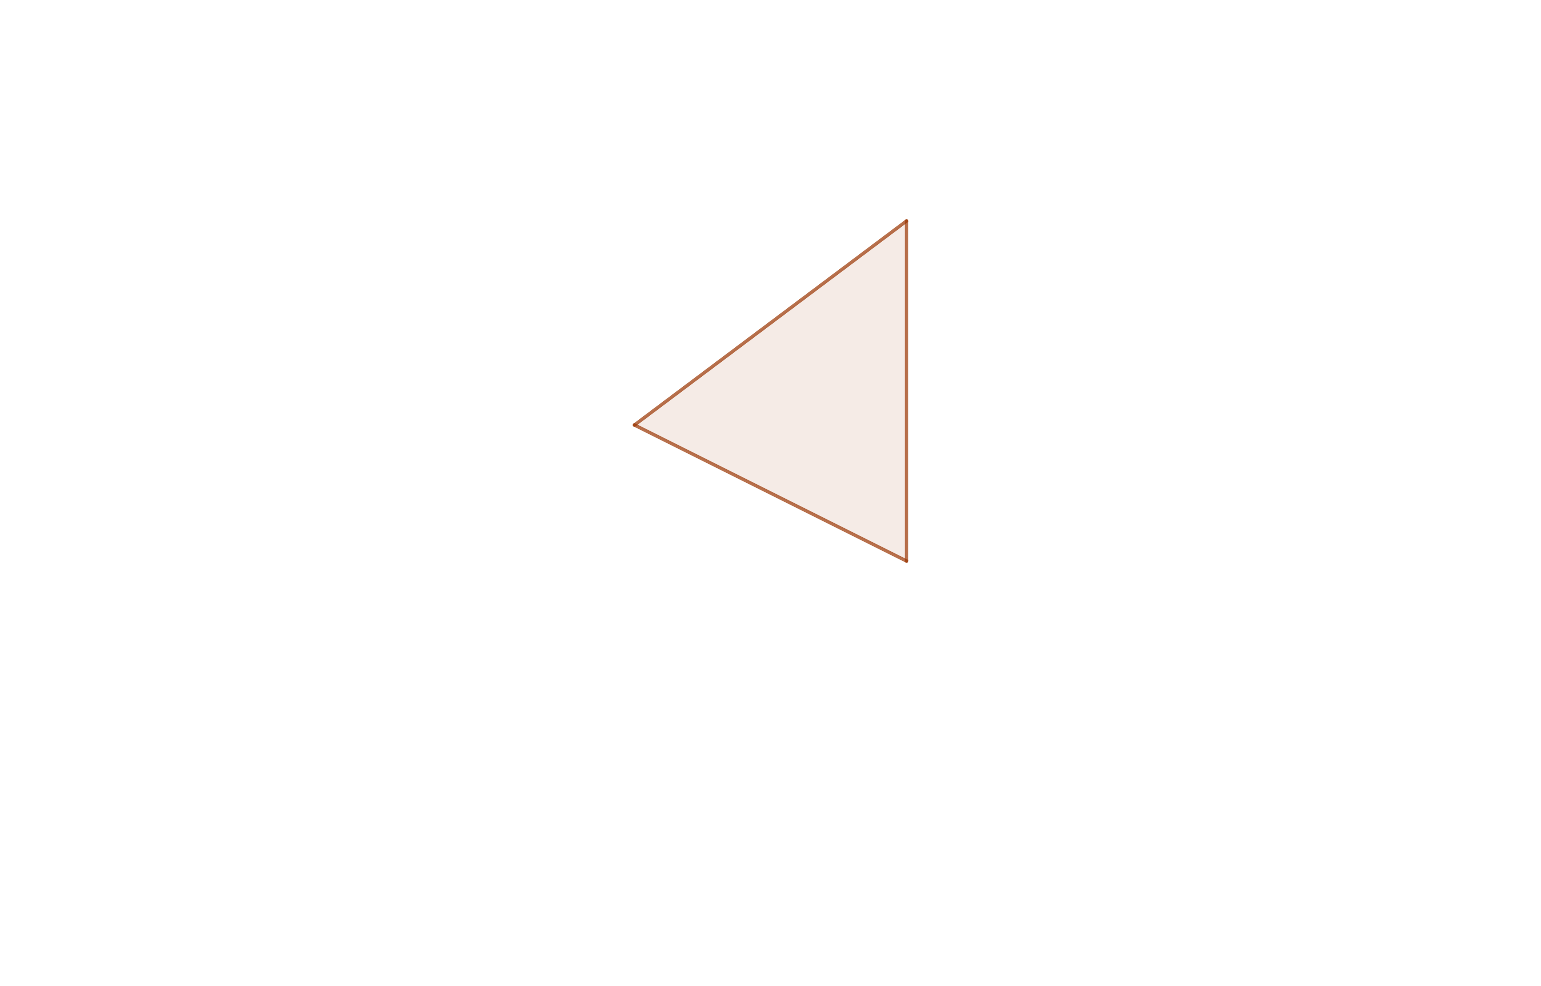 | 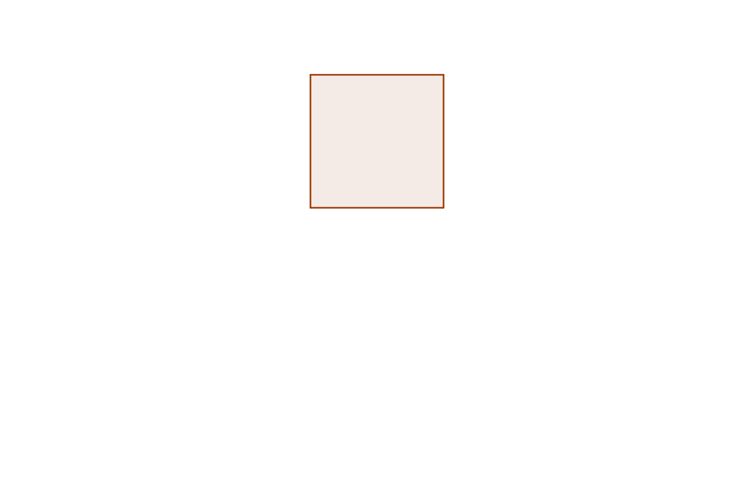 | 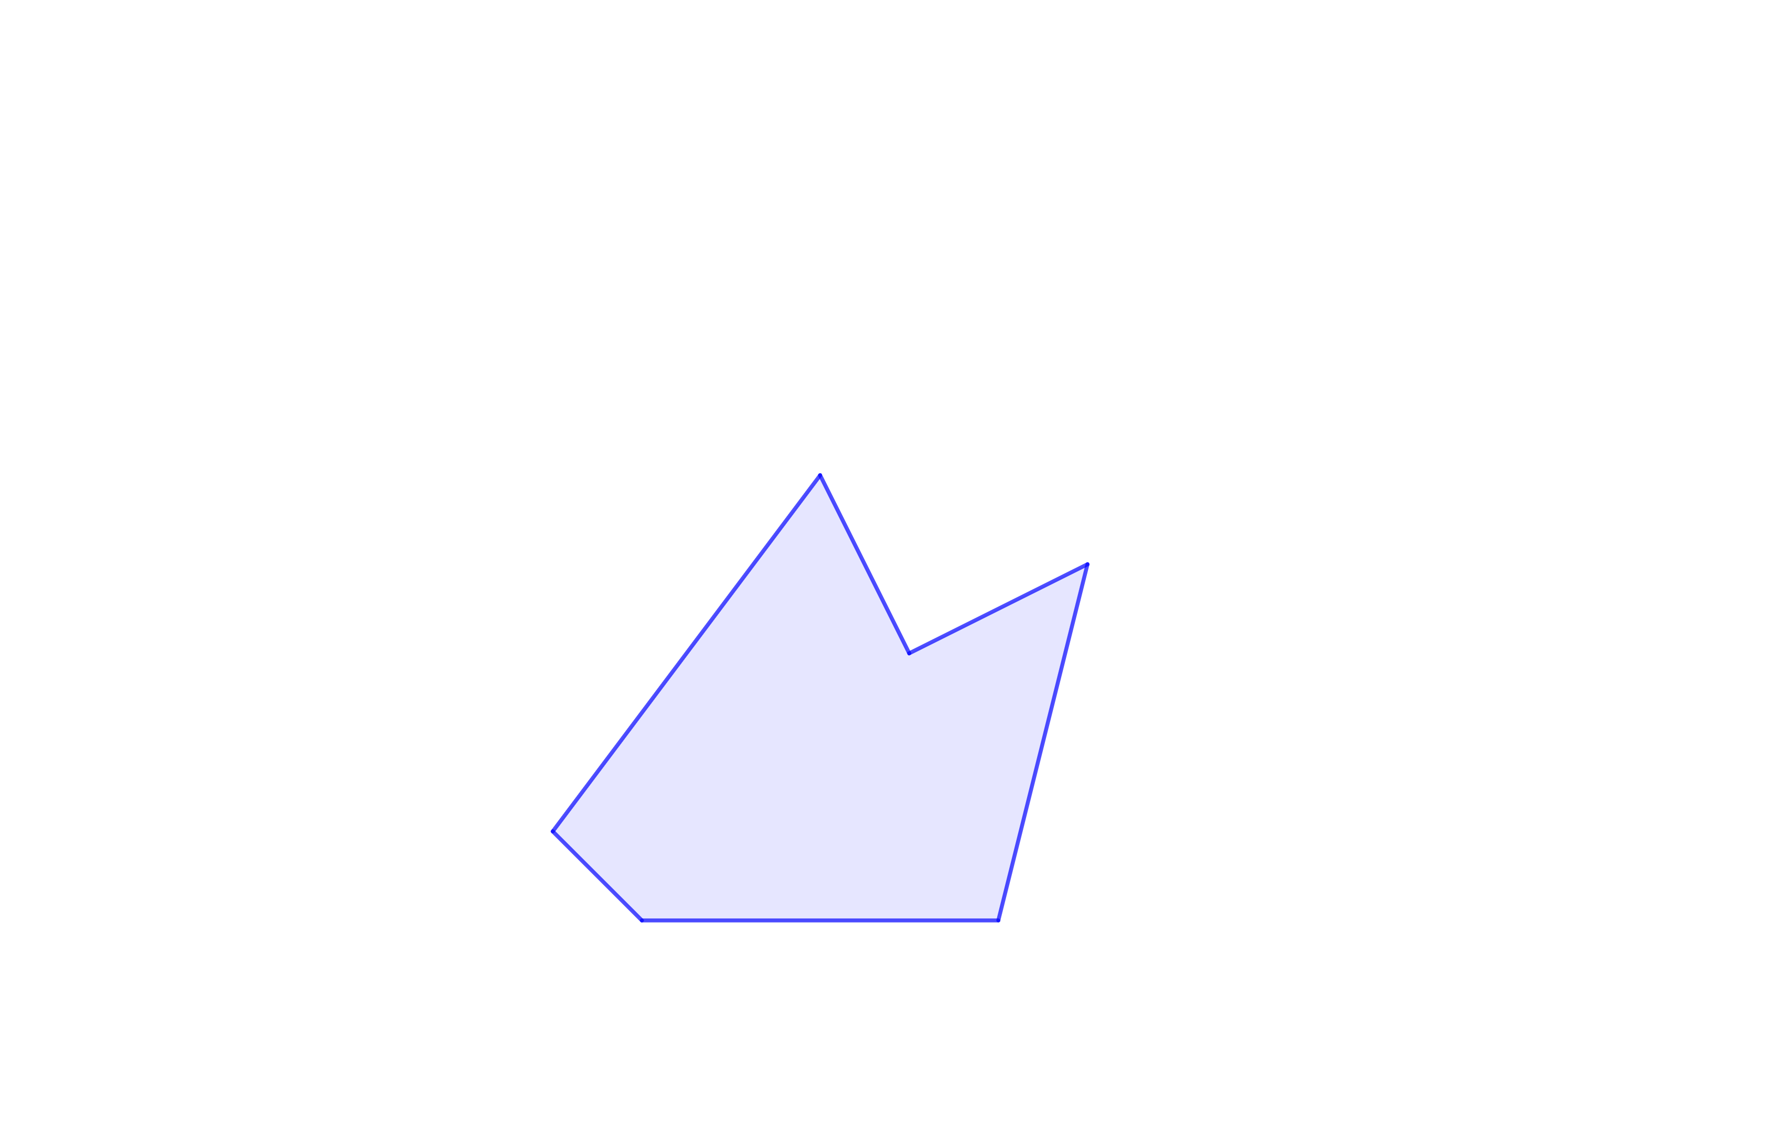
7-SIDED PLANE SHAPE
