SCRATCH THE SURFACE
One tin of paint covers the surface of approximately 10 m². How many tins of yellow and blues paint do we have to buy if we want to paint the surface of a handball court as the one shown in the picture?
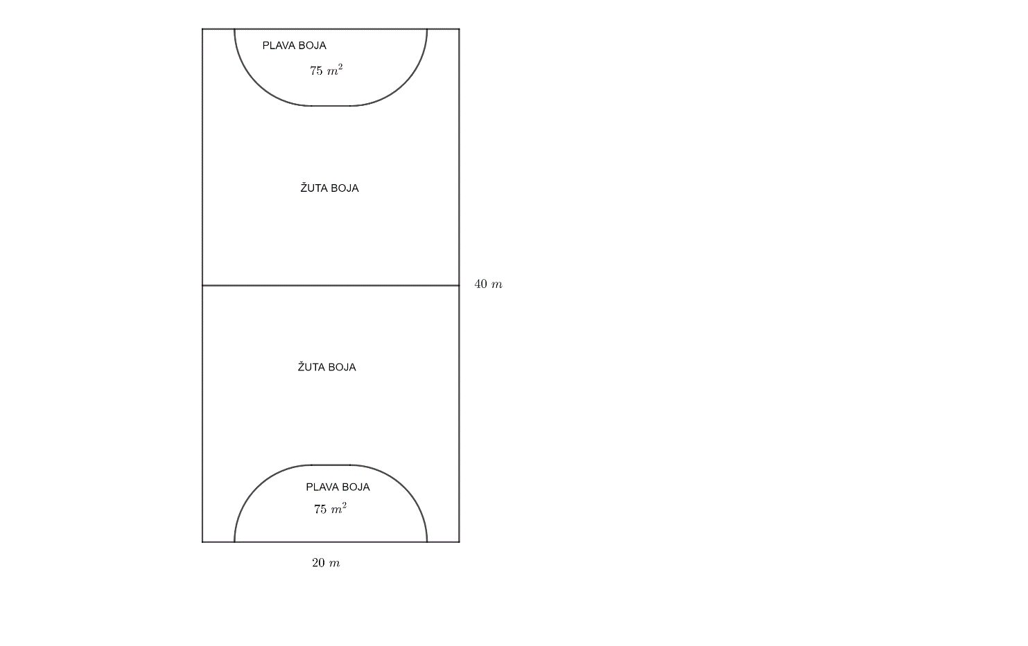
CALCULATION:

ANSWER:
_____________________________________________________________________________________
_____________________________________________________________________________________
_____________________________________________________________________________________

