Worksheet No. 1

The rectangular garden has a length of 62m and a width of 45m. Calculate the area of the garden if there is a house that occupies the garden area in a shape of square with a width of 14m

_________________________________________________________________

_________________________________________________________________

_________________________________________________________________

_________________________________________________________________

_________________________________________________________________

_________________________________________________________________

2. Simba has a rectangular field whose surface area is 4ha 80a with a length of 600m.

a) Calculate the width of the field.

b) How many rows of peppers can be planted in this field if the field can have two rows of peppers per each meter wide?

__________________________________________________________________

__________________________________________________________________

__________________________________________________________________

__________________________________________________________________

__________________________________________________________________

__________________________________________________________________

__________________________________________________________________

Worksheet No. 2

3. Calculate the length of the square warehouse, if its floor area is 81m2?

__________________________________________________________________

__________________________________________________________________

__________________________________________________________________

__________________________________________________________________

__________________________________________________________________

__________________________________________________________________

Worksheet No. 3

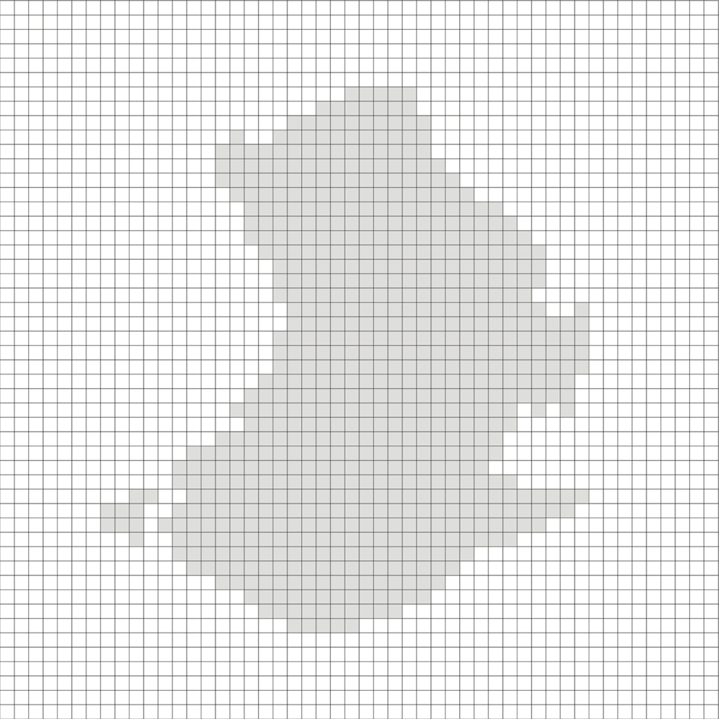

Worksheet No. 4

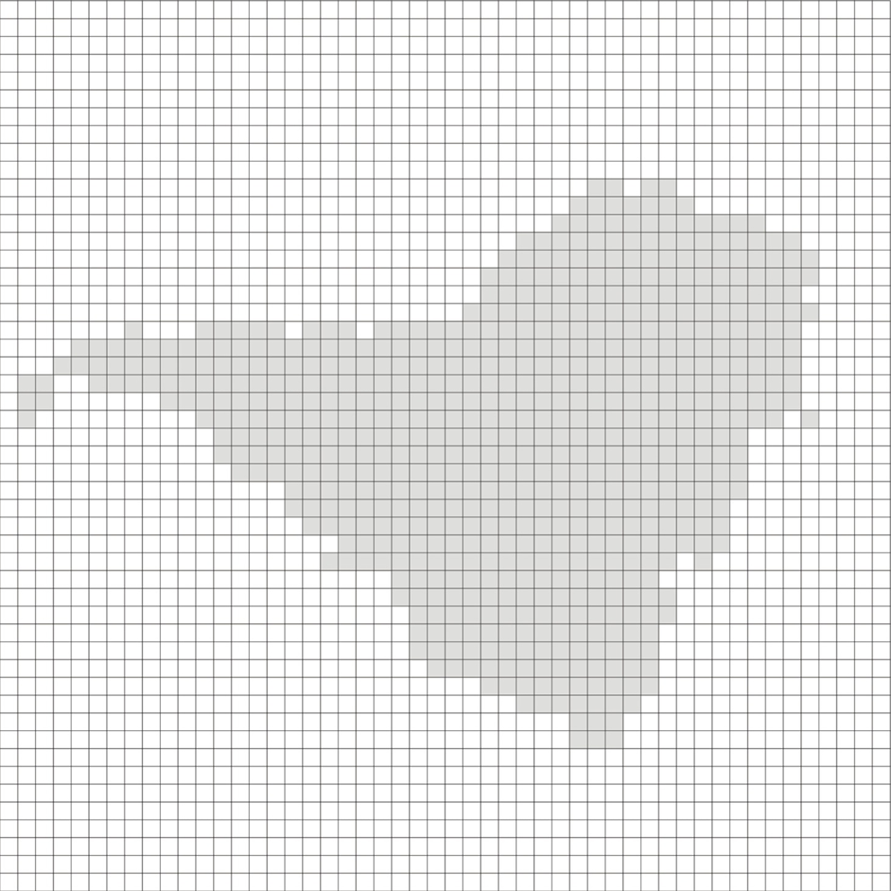

Worksheet No. 5

1. What is the surface area of a square if its perimeter is 16 m?

2. Calculate the area of the colored part of the figure according to the dimensions from the drawing.

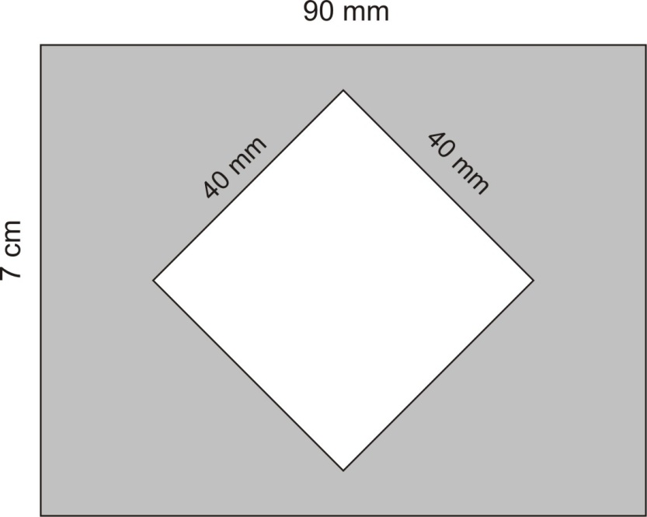

3. Calculate the perimeter of the square whose surface area is 64 cm2.

4. How much gasoline is needed to mow a square lawn with a side of 25 m, if 2 L of gasoline are needed for every 5 m2?